Desk Number________

Student Number_______________________

Student Name_______________________

**School of Science and Engineering**

**FINAL EXAMINATION**

Semester 2, 2019

**CSC1001 Introduction to Computer Science**

Examination Duration: 120 minutes

Reading Time: 10 minutes

This examination has __3__ questions.

**Exam Conditions:**

This is a FORMAL Examination

This is a RESTRICTED OPEN BOOK Exam. Maximum of one (1) sheet of handwritten or printed notes double sided are permitted

**Materials Permitted In The Exam Venue:**

Maximum of one (1) sheet of handwritten or printed notes double sided, a scientific calculator without the functionalities of programming and file storage and a paper-based dictionary are permitted. **NO OTHER MATERIALS PERMITTED**

**Materials To Be Supplied To Students:**

1 × 12 Page Answer Booklet, one answer sheet for multiple choice questions.

**Materials To Be Handed in After Exam:**

After exam, only answer sheet for multiple choice questions and the answer booklet are to be handed in.

Question 1. (15 × 2% = 30%)

Pick the correct option in each of the following sub-questions. Note that only ONE option is correct.

* 1. Binary number 1101011.101 and hexadecimal number 2DC.6 equal to decimal numbers:

1. 214. 625 and 732.375
2. 214. 625 and 732.6
3. 107.625 and 732.375
4. 107.625 and 732.6

Answer: C (Zhao Weibing)

* 1. Concerning Python language, which of the following statements is incorrect?

1. Python uses an interpreter to translate source codes into machine codes.
2. In Python, reserved words should not be used as variable names.
3. In Python, the value assigned to a variable name can be changed later in the program.
4. true and false are reserved words in Python.

Answer: D (Zhao Weibing)

1.3) Concerning the following program, which of the following statements is incorrect?`

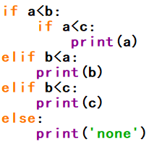

1. print(‘none’) will be executed when $a, b, c=20, 30, 10$.
2. print(b) will be executed when $a, b, c =20, 15, 10$.
3. print(c) will be executed when $a, b, c =10, 10, 20$.
4. print(a) will be executed when $a, b, c =10, 20, 30$.

Answer: A (Zhang Qianyu)

* 1. Concerning the object in Python, which of the following statements is incorrect?

1. Every object in Python has a unique ID.
2. The type of an object is determined automatically by Python interpreter according to its value.
3. Every variable is essentially a reference to an object.
4. The ID of an object may be changed during the execution of the program.

Answer: D (Zhang Qianyu)

* 1. Concerning stack and queue, which of the following statement is correct?

1. A stack can be accessed based on the “last in first out” principle and the time complexity of inserting an element into a stack is constant.
2. More than one elements of a stack can be accessed simultaneously if necessary.
3. Elements can be inserted at any time in a queue, but only the element that has been in the queue the shortest can be next removed.
4. The time complexity of removing an element from a stack or a queue is linear.

Answer: A (Liu Guolong)

* 1. Concerning the following program, which of the following statement is incorrect?

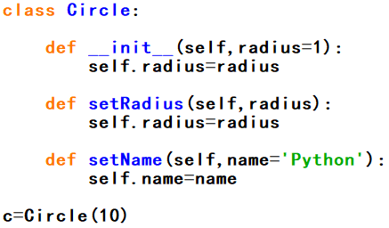

1. The purpose of __init__() is to initialize the data fields in class Circle().
2. The output of the statement print(c.name) is ‘Python’.
3. The output of the statement print(c.radius) is 10.
4. When creating an object from class Circle(), it is acceptable that no arguments are input.

Answer: B (Liu Guolong)

* 1. What is the output of the following program?

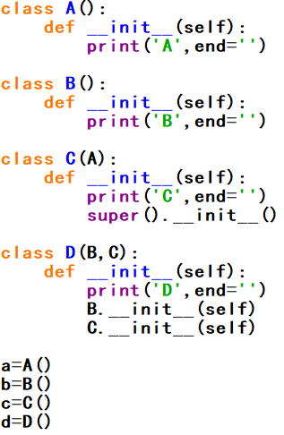

1. ABCDABAC
2. ABCADBAC
3. ABCADBCA
4. ABCDABCA

Answer: C (Wang Xuchu modified by Ben)

* 1. Which of the following statements is incorrect?

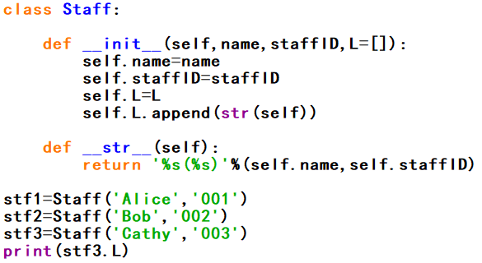

1. All objects of Staff class will not share the same data field L because list is immutable.
2. The output of the above program is

['Alice(001)', 'Bob(002)', 'Cathy(003)']

1. When objects of Staff class are created, their data field L will automatically append themselves(represented by its string form) as elements.
2. In this case, the __init__() method will be automatically invoked when an object of Staff class is created.

Answer: A (Wang Xuchu modified by Ben)

* 1. What is the output of the following code?

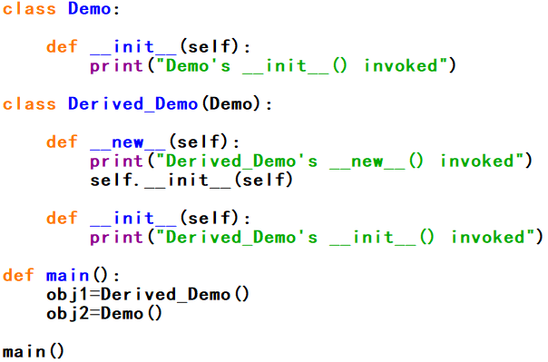

1. Derived_Demo's __init__() invoked

Derived_Demo's __new__()invoked

Demo's __init__() invoked

1. Derived_Demo's __new__() invoked

Derived_Demo's __init__() invoked

Demo's __init__() invoked

1. Derived_Demo's __new__() invoked

Derived_Demo's __init__() invoked

Demo's __new__() invoked

Demo's __init__() invoked

1. Derived_Demo's __init__() invoked

Derived_Demo's __new__() invoked

Demo's __init__() invoked

Demo's __new__() invoked

Answer: B (Wang Xuchu modified by Ben)

* 1. Concerning class inheritance in Python, which of the following statements is incorrect?

1. Inheritance enables you to define a general class and later extend it to define more specialized classes.
2. A subclass may inherit data fields and methods from its superclass.
3. When defining a subclass, the name of its superclass should be placed in the parenthesis after the name of the subclass.
4. A subclass is a subset of its superclass.

Answer: D (Li Yishu)

* 1. Concerning tuple, which of the following statement is correct?

1. A tuple is a sequence of elements which are indexed from 1.
2. Tuple is more efficient compared with list in Python.
3. Tuples are comparable and two tuples are equal if their first elements are equal.
4. ‘t=(50,)’ creates tuple t with two elements, one is 50 and the other one is None.

Answer: B (Li Yishu)

* 1. Concerning the following program, which of the following statements is correct?

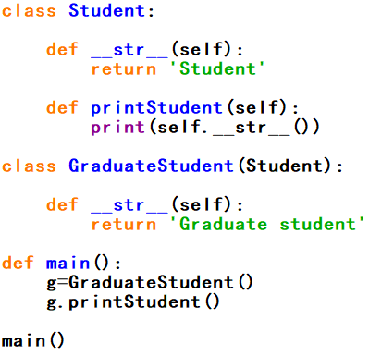

1. The output of this program is ‘Student’.
2. The output of this program is ‘Graduate student’.
3. There is attribute error “'GraduateStudent' object has no attribute 'printStudent'”
4. In class GraduateStudent(), method __str__() is inherited from class Student(), but has not been overridden.

Answer: B (Li Yishu)

* 1. Concerning the following program, which of the following statements is correct?

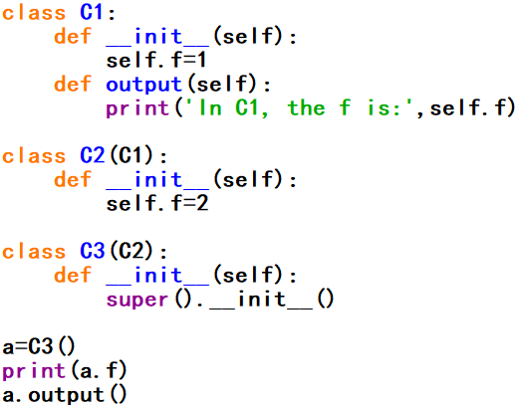

1. On the inheritance chain defined in this program, class C1() has no superclass.
2. In this program, the data field “f” in class C1() won’t be inherited by class C3().
3. When running this program, an error will be triggered.
4. The output of this program is:

2

In C1, the f is: 1

Answer: B (Ben)

* 1. Concerning data structure and algorithm, which of the following statements is incorrect?

1. Data structure concerns how to organize and access data.
2. An algorithm is a step-by-step procedure for performing some task in a finite amount of time.
3. The quality of an algorithm can be determined by measuring its running time only.
4. When analysing the running time of an algorithm, two commonly used approaches are experimental analysis and asymptotic analysis.

Answer: C (Ben)

* 1. Concerning algorithm analysis, which of the following statements is incorrect?

1. In algorithm analysis, we focus on the growth rate of the running time as a function of the input size.
2. The result of asymptotic analysis does not depend on the hardware and software environment where you perform the algorithm.
3. An algorithm with a time complexity of O($n$) will always perform better than an algorithm with a time complexity of O($2^{n}$).
4. A polynomial time algorithm is usually considered as tractable.

Answer: C (Ben)

Question 2. (10 × 4% = 40%)

Pick the correct option/s in each of the following sub-questions. Note that there may be MULTIPLE correct options for each sub-question(one, two, three or four correct options all possible). With any wrong options will get 0 point for that problem, while missing any correct options will get half(2 points).

* 1. Concerning the following program, which of the following statement/s is/are correct?

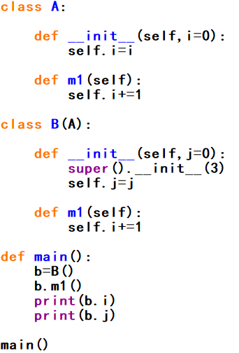

1. Class B() has only one superclass.
2. In class B(), the initializer of A() is accessed by calling function super().
3. Class B() has only one data field.
4. The output of b.i and b.j are 4 and 0.

Answer: ABD (Zhao Weibing)

* 1. Concerning the following program, which of the following statement/s is/are correct?

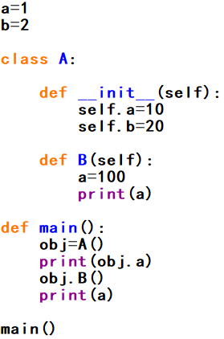

1. In this program, three different variables a have been defined.
2. Data field a of class A() can only be accessed within the class definition.
3. The value of global variable a will initially be set as 1, and then changed to 100.
4. The output of this program is:

10

100

100

Answer: A (Zhang Qianyu)

|  |  |  |  |
| --- | --- | --- | --- |
| * 1. Concerning the following program, which of the following statement/s is/are correct?      1. The output of the program in the terminal is:   Student(Python,18)  Student(Python,118000000,graduateStudent)   1. The __printPerson() method in the graduateStudent() class has been invoked through g.printPerson(). 2. The printPerson() method has been overridden in Student() class. 3. The __getInfo() method has been overridden in graduateStudent() class.   Answer: AC (Liu Guolong, modified by Ben) |  |  |  |

* 1. Concerning algorithm analysis, which of the following statement/s is/are correct?

1. The big-Oh notation allows us to say that a function f(n) is less than or equal to another function g(n) up to a constant factor when n is large enough.
2. The big-Oh notation is usually used to characterize the running time of an algorithm in the asymptotic sense.
3. Function $5n^{4}+6n^{3}+2n^{2}+2^{n}+2n$ is O($n^{4}$).
4. When we analyse an algorithm, we are usually interested at its average performance regardless of the input size.

Answer: AB (Wang Xuchu)

* 1. Concerning recursion, which of the following statement/s is/are correct?

1. Recursion is a technique by which a function makes one or more calls to itself during execution.
2. A recursive algorithm should have one or more base cases which is non-recursive.
3. Recursion is used for performing a definite amount of repetitive tasks, the same as for loop.
4. All the recursive calls are executed successively, that is, one will not be executed until the previous one finishes completely.

Answer: AB (Li Yishu modified by Ben)

* 1. Concerning the binary search algorithm, which of the following statement/s is/are correct?

1. This algorithm is able to find out whether a target element exists in a given sequence of elements.
2. Binary search algorithm can be applied on an unsorted sequence.
3. The time complexity of binary search is O(log n).
4. Binary search is usually more efficient than sequential search.

Answer: ACD (Ben)

* 1. Concerning the class in Python, which of the following statement/s is/are correct?

1. The __init__() method is automatically invoked when an object is constructed, given that the __new__() method has not been overriden.
2. The __str__() method is a private method which returns a string description for the object.
3. A subclass is more specific than its superclass in the sense that it may have more data fields and methods.
4. Polymorphism means different functions are needed when you want to change the data type of parameter to its subclass.

Answer: AC (Liu Guolong modified by Ben)

* 1. Concerning queue, which of the following statement/s is/are correct?

1. Data are saved sequentially in a queue.
2. Data can only be removed from the end of a queue.
3. Data can only be inserted at the front of a queue.
4. Data in a queue must be of the same data type.

Answer: A (Wang Xuchu)

* 1. Concerning linked list, which of the following statement/s is/are correct?

1. The time complexity of removing the head node of a singly linked list is constant.
2. The time complexity of removing the tail node of a singly linked list is constant.
3. A node in a singly linked list usually contains two references pointing to its previous and next node.
4. We can identify the tail of a singly linked list as the node having None as its next reference.

Answer: AD (Li Yishu modified by Ben)

* 1. Concerning a binary tree, which of the following statement/s is/are correct?

1. In a binary tree, data are saved hierarchically.
2. In a non-empty binary tree, there is one and only one node that has no parent node.
3. In a binary tree, some nodes may have multiple parent nodes.
4. In a binary tree, every node has either zero or two child nodes.

Answer: AB (Ben)

Question 3. (6%+10%+14% = 30%)

Answer the following questions.

* 1. After this semester you are going to receive your grade transcript from university, unfortunately some staff just puts every transcript in the wrong envelope. Given n to be the total number of transcripts, define a recursive function def fun(n) to calculate how many possibilities that every transcript is wrong for each student. For example: if n=4, the function should return 9.

Answer: (Wang Xuchu) 6%

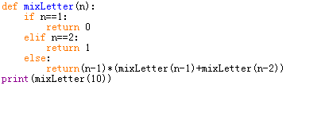

* 1. Concerning the following program

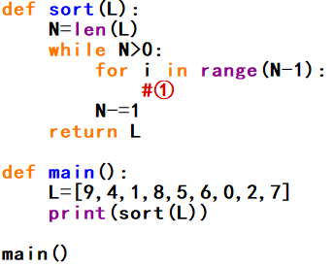

Answer the following questions:

1. This program is to sort a given list with descending order(the output of the above program is [9, 8, 7, 6, 5, 4, 2, 1, 0]). Use bubble sort to implement the sort. Please fill the blank ① to complete the program(maybe more than one line of code are needed.)
2. What is the time complexity of bubble sorting algorithm?

Answer: (Li Yishu)

A.6%

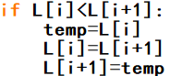

B.O（n²）4%

* 1. Concerning the following program, and assume that input t will be a reference pointing to the root of a binary tree.

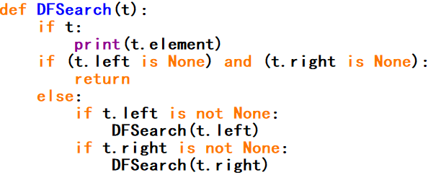

Answer the following questions:

1. What is the purpose of the above function?
2. If input t is referencing to the root of the following tree, what would be the outputs of this function?

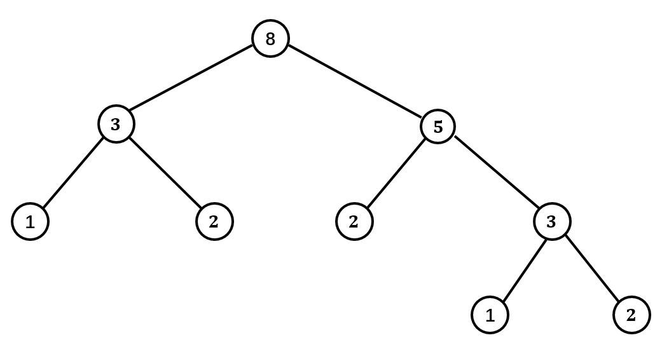

1. Modify the above program in order to check whether a target integer n is in the tree. Define a function that can return a list that stores the positions(use tuple (x,y) to represent xth level and yth node starting from left at that level) of all target integers. And if no, return empty list. You may use the following program and fill in the blanks ①②③④.Notice that one line of code for each blank is enough. D is a dictionary and L is a list.

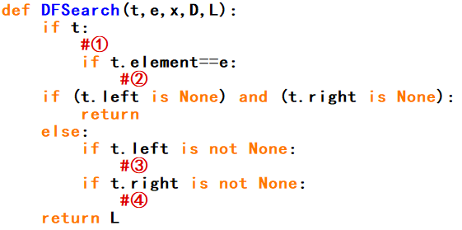

Here is a sample test program(the tree in question (B) is used.):



Answer:(Ben)

1. Print out the elements of all nodes on the tree(or subtree) with root being t based on depth first principle. 3%
2. 3%



1. ①D[x]=D.get(x,0)+1

②L.append((x,D[x]))

③DFSearch(t.left,e,x+1,D,L)

④DFSearch(t.right,e,x+1,D,L) 8%

**END OF EXAMINATION**